TOURNAMENT HUB

Aim : creating tournament hub app.

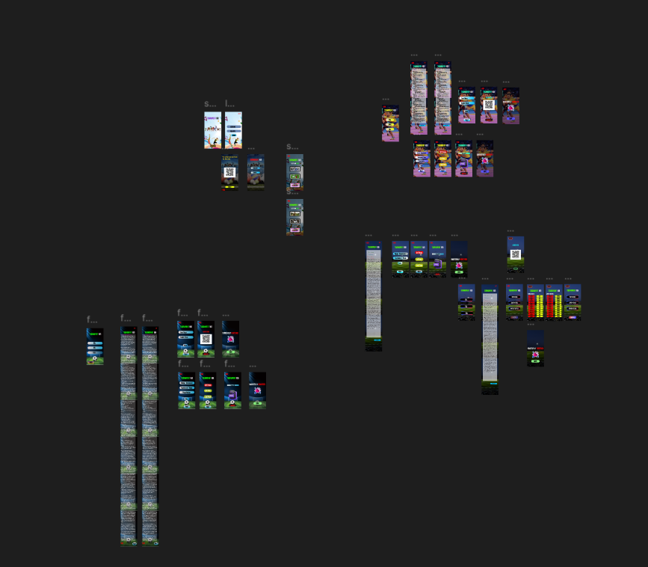

Procedure:

**Step 1: Set Up Your Figma File**

1. **Create a New File**:
   * Open **Figma** and select **File > New** to create a new design file.
2. **Create Frames (Artboards)**:
   * Use Figma's **Frame Tool (F)** to create separate frames for each screen of the app.
   * For mobile design, use **iPhone 13/14/SE (375x812)** frame dimensions as a base for creating the layout.
   * Define frames for key screens like **Home**, **Tournaments**, **Leaderboard**, **Team Profile**, **Tournament Details**, **Registration**, **Settings**, etc.

### **Step 2: Define the App Structure and Features**

Before you start designing, plan out the core features of the **Tournament Hub App**. Here's an overview of essential features:

1. **Splash Screen**:
   * Display the app logo and tagline briefly.
   * Transition to the onboarding or login screen.
2. **Onboarding** (optional):
   * Introduce the app to new users and explain its features (e.g., discovering tournaments, joining teams, tracking progress).
3. **Home Screen**:
   * Dashboard showing upcoming tournaments, ongoing tournaments, and featured events.
   * Include navigation links to tournament categories, leaderboards, and notifications.
4. **Tournaments Screen**:
   * Browse and filter tournaments based on categories like **game type**, **region**, or **level**.
   * Option to search and view more detailed tournament information.
5. **Tournament Detail Screen**:
   * Provides detailed information about a specific tournament (e.g., tournament description, registration details, start date, prizes, etc.).
6. **Leaderboard**:
   * Display current rankings for ongoing tournaments.
   * Show detailed stats like scores, teams, and individual rankings.
7. **Registration Screen**:
   * Users can sign up or register for a tournament, create/join a team, and view their tournament schedule.
8. **Team Profile**:
   * View and manage team information, members, and tournament performance.
9. **Settings**:
   * Manage user profile, preferences, notifications, and app settings.

### **Step 3: Design the Screens**

#### **1. Splash Screen**

* **Logo and Tagline**: Center your app’s **logo** with a **short tagline** underneath (e.g., “Join. Compete. Win.”).
* **Background**: Use a **clean background** with a subtle gradient or an image that represents tournaments (e.g., gaming, sports).
* **Transition**: Add a smooth transition to the onboarding or home screen after a few seconds.

#### **2. Onboarding Screens (optional)**

* **Screen 1**: Show the app’s **purpose**. For example, “Welcome to Tournament Hub! Discover tournaments, compete with others, and rise to the top!”
* **Screen 2**: Highlight key features like “Join teams”, “Track tournaments”, “See leaderboards”.
* **Screen 3**: A **Call-to-Action (CTA)** to sign up or log in: “Create an account and get started!”
* **Navigation**: Allow users to **swipe through** the screens, with a **Skip** and **Next** button.

#### **3. Home Screen**

The Home screen is the **main dashboard** where users can discover tournaments and get a quick overview of upcoming events.

* **Navigation Bar**:
  + **Logo** at the top-left corner.
  + **Menu icon** (hamburger) on the top-right for app navigation (Settings, Profile, etc.).
* **Upcoming Tournaments Section**:
  + A **carousel** or **horizontal scrolling list** of upcoming tournaments.
  + Each tournament card should show the **game name**, **tournament date**, and **entry fee**.
  + Option to tap to see **more details** about each tournament.
* **Featured Tournaments**:
  + Highlight the **most popular** or **top-ranked tournaments**.
* **Quick Actions**:
  + Include quick links or buttons like **"Join a Tournament"**, **"Create a Team"**, **"View Leaderboard"**.

#### **4. Tournaments Screen**

The Tournaments screen allows users to browse and filter tournaments by categories such as **game type**, **region**, or **difficulty level**.

* **Category Filters**:
  + Filters for **Game Type** (e.g., eSports, Sports, Casual), **Region**, and **Tournament Level** (Beginner, Intermediate, Pro).
  + Use **dropdown menus** or **tabs** for easy access.
* **Tournament Listings**:
  + Display **tournament cards** in a grid or list format, each showing the name, game type, region, date, and registration button.
  + Add **pagination** or **infinite scroll** for easy browsing.
* **Search Bar**:
  + A prominent **search bar** at the top to search tournaments by name or keyword.

#### **5. Tournament Detail Screen**

Once a user taps on a tournament, they’ll be taken to the tournament detail page with all relevant information.

* **Tournament Header**:
  + Display the tournament **name**, **start date**, and **game type**.
  + Show tournament **prizes**, **registration deadlines**, and **number of participants**.
* **Description**:
  + A section with a **brief description** of the tournament and any **rules** or guidelines.
* **Registration**:
  + A clear **call-to-action button** like **“Register Now”** or **“Join Tournament”**.
  + Display options to **join as an individual** or **create/join a team**.
* **Teams & Participants**:
  + Include a list or section that shows **team members** (if applicable) or **individual participants**.

#### **6. Leaderboard Screen**

The leaderboard should showcase **rankings** and **performance stats** for ongoing or past tournaments.

* **Ranking List**:
  + Show the **top teams** or **top players**.
  + Display details like **team names**, **points**, and **rankings**.
* **Filter by Tournament**:
  + Allow users to filter by specific tournaments or categories (e.g., “Today’s Rankings”, “Weekly Rankings”, “All-time”).
* **User’s Ranking**:
  + Highlight the user’s own position if they are participating in a tournament.

#### **7. Registration Screen**

Users need an intuitive and easy way to register for tournaments and manage their team.

* **Registering for a Tournament**:
  + Show tournament details, including **entry fees** and **prizes**.
  + **Team Creation**: Option to create or join a team. If creating a team, users can **invite friends** or **search for teammates**.
  + Include options like **solo registration** or **team registration**.
* **Confirmation**:
  + After registration, display a **confirmation screen** with tournament details and next steps.

#### **8. Team Profile Screen**

The team profile screen allows users to manage their team’s information and tournament performance.

* **Team Details**:
  + Display the **team name**, **logo**, and **members**.
  + Show **team stats**, such as **number of tournaments played**, **wins**, and **ranking**.
* **Invite Members**:
  + Allow users to invite other players to join their team.
* **Upcoming Tournaments**:
  + Show the **team’s upcoming tournaments**, with **registration status**.

#### **9. Settings Screen**

Allow users to manage their preferences and account settings.

* **Profile Management**:
  + Users can update their profile, including their **name**, **photo**, and **preferences**.
* **Notifications**:
  + Include options to manage **push notifications**, such as tournament reminders and leaderboard updates.
* **App Settings**:
  + Preferences for language, theme (dark/light mode), and account (e.g., change password or log out).

### **Step 4: Visual Design**

#### **1. Color Scheme**

* Use a **dynamic color scheme** that reflects the competitive and energetic nature of tournaments.
  + For example, use **dark tones** for the background (black or dark gray) with **vibrant accent colors** (like neon blue, green, or orange) for buttons, highlights, and CTAs.
* Ensure good contrast for **readability**.

#### **2. Typography**

* Choose **bold and modern fonts** to match the competitive spirit of a tournament app.
  + Example: Use **Montserrat** or **Roboto** for headings and **Lato** or **Open Sans** for body text.

#### **3. Icons and Images**

* Use **clean, minimalistic icons** for actions like **search**, **filters**, **team**, and **leaderboard**.
* Add **high-quality images** of tournaments or game logos to make the app visually appealing.

### **Step 5: Prototype and Interactions**

1. **Link Screens**: Use Figma’s **Prototyping feature** to connect screens and create interactive flows.
   * Link buttons like **“Register Now”**, **“Join Tournament”**, and **“See Leaderboard”** to their respective screens.

Result:

SuccesFully Created Tournament hub.